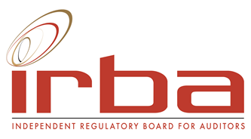

APPLICATION AND/OR NOMINATION FORM
SUBJECT MATTER EXPERT TO SUPPORT THE ACCREDITATION COMMITTEE (ACCOM)

Nomination position | Subject Matter Expert (to support the ACCOM)
Candidate information
Full names
Surname
Gender*
Race*
Address 1
Address 2
Town / City
Telephone Landline
Telephone Mobile number
E-mail
Nationality
Language
Country of residence
Professional designation/s
Professional affiliations
Prior PAAB/IRBA involvement
- Committees
- Terms served
(The PAAB is the IRBA’s predecessor body)
Present occupation and employer
Educational background

Professional experience

Subject matter experience in the applicable subject areas below:
Auditing and Assurance | Detailed description of experience (with a focus on the requirements included in the advert)
Auditing and Assurance | NQF level (1-10) to which this experience relates
Managerial Accounting and Finance | Detailed description of experience
Managerial Accounting and Finance | NQF level (1-10) to which this experience relates
South African Corporate and Business law | Detailed description of experience
South African Corporate and Business law | NQF level (1-10) to which this experience relates
Explain why you wish to be a Subject Matter Expert.

Have there been, or are there any disciplinary actions against you by accounting or other professional bodies, regulators or others? (including any in progress)
If yes, please describe.
Will you be able to meet the time commitments to serve as a Subject Matter Expert for the IRBA’s ACCOM?

* This information is required to ensure gender and demographic representavity on the IRBA

