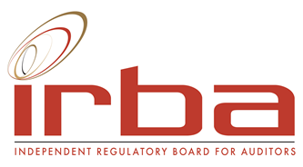

APPLICATION AND/OR NOMINATION FORM
ACCREDITATION COMMITTEE (ACCOM) AND/OR
SUBJECT MATTER EXPERT TO SUPPORT ACCOM

Nomination position per advert:
ACCOM Member | Yes / No
Subject Matter Expert (to support the ACCOM) | Yes/ No
Candidate information
Full names
Surname
Gender*
Race*
Address 1
Address 2
Town / City
Telephone Landline
Telephone Mobile number
E-mail
Alternative E-mail
Nationality
Language
Country of residence
Professional designation/s
Professional affiliations
Prior PAAB/IRBA involvement
- Committees
- Terms served
(The PAAB is the IRBA’s predecessor body)
Present occupation and employer
Educational background

Professional experience

FOR ACCOM APPLICANTS- Description of skills and experience relevant to the role:
ACCOM: Direct or indirect experience in Auditing and Assurance as noted in the advert. | Detailed description of experience (with a focus on the areas included in the advert)
FOR SME APPLICANTS- Subject matter experience in the applicable subject areas below:
Auditing and Assurance | Detailed description of experience (with a focus on the requirements included in the advert)
Auditing and Assurance | NQF level (1-10) to which this experience relates:
Taxation | Detailed description of experience
Taxation | NQF level (1-10) to which this experience relates:
South African Corporate and Business law | Detailed description of experience
South African Corporate and Business law | NQF level (1-10) to which this experience relates:
Explain why you wish to be an ACCOM member or Subject Matter Expert.

Have there been, or are there any disciplinary actions against you by accounting or other professional bodies, regulators or others? (including any in progress)
If yes, please describe.
Will you be able to meet the time commitments to serve as an ACCOM member of Subject Matter Expert?

* This information is required to ensure gender and demographic representavity on the IRBA.

