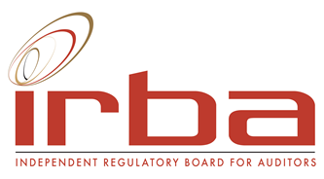

APPLICATION AND/OR NOMINATION FORM
EDUCATION AND TRANSFORMATION STATUTORY COMMITTEE

Nomination position
Nomination for
Candidate information
Full names
Surname
Gender*
Race*
Address 1
Address 2
Town / City
Telephone Landline
Telephone Mobile number
Fax
E-mail
Nationality
Language
Country of residence
Professional designation/s
Professional affiliations
Prior PAAB/IRBA involvement
- Committees
- Terms served
(The PAAB is the IRBA’s predecessor body)
Present occupation and employer
Educational background

Professional experience

Appointments/activities/experience in education, transformation and/or regulation, highlighting experience specifically in one or more of the following areas that would contribute to your role as a member of EDCOM:
- Experience in auditing in the public sector.
- Experience gained at a large auditing firm.
- Experience in the role of transformation officer at a firm.
- Experience in accreditation and/or monitoring of another body/institution/organisation or programme.
- Experience in developing and/or executing transformation strategies.
- Experience at a SETA; and
- Experience in relation to the skill set required of professionals in the future.

Explain why you wish to be a member of the IRBA EDCOM.

Explain your objectives as a member of the IRBA EDCOM.

Explain how your skills, knowledge and experience are relevant to this position.
Has there been, or are there any disciplinary actions against you by accounting or other professional bodies, regulators or others? If yes, please describe.
Will you be able to meet the time commitments for the IRBA EDCOM?
(4 full day meetings per annum)

* This information is required to ensure gender and demographic representavity on the IRBA

