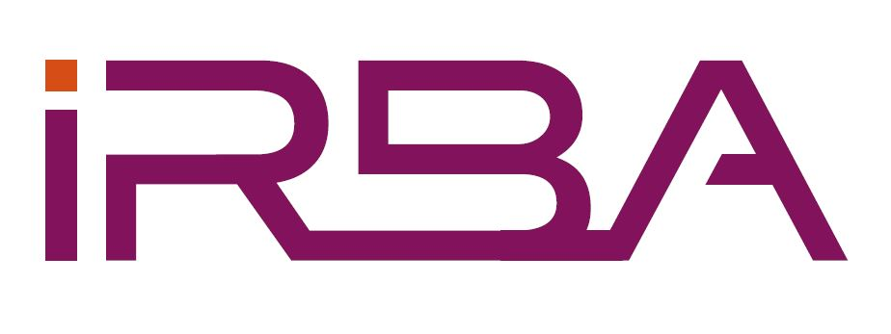

Guidelines for Public Observers Attending Meetings of the

Committee for Auditor Ethics (CFAE)

- The meetings of the CFAE are held at the offices of the Independent Regulatory Board for Auditors (the IRBA): Building 2, Greenstone Hill Office Park, Emerald Boulevard, Modderfontein.
- Public observers who wish to attend a meeting of the CFAE are required to complete and return an observer registration form to the secretariat at least 7 days prior to the meeting. Persons who have not given advance notification of their attendance will be permitted to attend the meeting at the discretion of the CFAE.
- Public observers are asked to report to the secretariat on arrival to sign the attendance register.
- The CFAE agenda and attachments for individual items will be circulated in advance of the meeting via e-mail, to attendees. Copies of attachments circulated thereafter, or tabled, will be made available at the meeting.
- The CFAE agenda may be divided into items that are to be discussed in the session open to the public observers and items of an administrative or confidential nature that are to be discussed in a closed session which is not open to public observers.
- Attachments that are made available to public observers are for information purposes only, and may not be distributed to the general public or used for any other purpose.
- Public observers are not permitted to vote or to engage in any discussion or debate during the meeting.
- Public observers are required to make their own travel arrangements at their own cost.
- Public observers are expected to comply with the usual business ethics during their visit to the IRBA buildings.

COMMITTEE FOR AUDITOR ETHICS (CFAE)

REGISTRATION AND AGREEMENT TO ABIDE BY GUIDELINES FOR PUBLIC OBSERVERS ATTENDING MEETINGS OF CFAE

Name:
Title:
Organisation:
Postal address:
Telephone number (business):
Telephone number (cellular):
Email address:
Date of meeting:

Declaration:
I acknowledge that I have read and understood the Guidelines for Public Observers Attending Meetings of the Committee for Auditor Ethics (CFAE) as set out in the attachment and agree to abide by those terms and conditions.

Signature:
Date:

Please submit completed form to:
Cathrine Ndomba – Personal Assistant: Standards – CNdomba@irba.co.za

