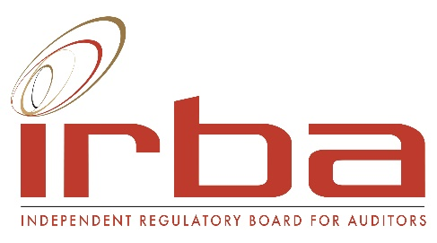

FORM 4

INDEPENDENT REGULATORY BOARD FOR AUDITORS
(Established under Section 3 of Act 26 of 2005)

APPLICATION BY AN INDIVIDUAL REGISTERED AUDITOR FOR RECOGNITION AS A TAX PRACTITIONER WITH THE IRBA AS THE RECOGNISED CONTROLLING BODY IN TERMS OF SECTION 240A OF THE TAX ADMINISTRATION ACT, 2011

I, a Registered Auditor, hereby request to be recognised as a tax practitioner with the IRBA as my Recognised Controlling Body and submit the following information in support of my request:

1. PERSONAL DETAILS

Surname:
Forename(s):
IRBA individual registration number:
SA identity number:

Passport details are only required if the Registered Auditor is not a holder of a valid South African Identity Document and has not filled in a valid South African Identity Number above:

Passport number:
Country of issue of passport:
Date of issue of passport:
Date of expiry of passport:

2. TAX DETAILS:

Tax practitioner number:
Personal Income tax reference number:

Please note that in order for SARS to confirm your registration with the IRBA, the above information is mandatory.

I confirm that my contact information on the IRBA’s registers is correct, and I undertake to inform the IRBA within 30 days if any of my contact details change.

I CERTIFY THAT THE ABOVE INFORMATION IS TRUE AND CORRECT IN EVERY DETAIL.

I attach proof of payment of the prescribed application fee in the amount of R3,570 for the year ending 31 March 2022.

I understand that the application fee is not pro-rated and that I will be invoiced for a tax practitioner annual fee, over and above my registration renewal annual fee, on an annual basis with effect from 1 April of the financial year following my registration. Please note that the IRBA’s financial year runs from 1 April to 31 March.

The IRBA’s banking details are:

Bank: Standard Bank
Branch: Eastgate
Branch Code: 018505
Account Number: 221290532

Please note we cannot start processing your application without confirmation of payment.

If you withdraw or cancel your application for recognition as a tax practitioner, you will be refunded the application fee less a 15% administration fee on submission to registry@irba.co.za of proof of your banking details.

______________________________________ ___________________________________________
Date Signature of applicant

Please submit your completed form with proof of payment to registry@irba.co.za.

Please note that in order for the IRBA to engage with you, it will have to Process certain Personal Information which belongs to you, which Processing is described and explained under the specific and informative IRBA Processing Notices, housed for ease of reference on IRBA’s website at https://www.irba.co.za/library/popi-act, which we ask you to download and read. By providing us with the required Personal Information, such act will be taken as an indication that you have read and agree with the provisions described under the Processing Notice and, where applicable, you consent to the processing by us of your Personal Information.

FOR IRBA USE ONLY
 | Date | Signature
Registrations Manager approval and letter signed

