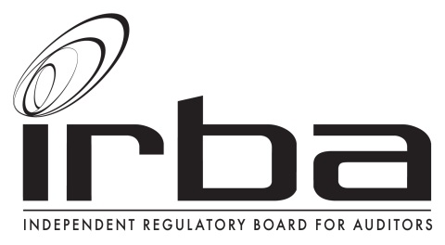

MEMORANDUM

To: Imran Vanker
From: Imre Nagy and Team
Date: 11 October 2016
Subject: Proposed Guide for Registered Auditors – Considerations for an Auditor or a Reviewer of a Company which is Factually Insolvent

Dear Imran

We thank you for the opportunity to comment on the Proposed Guide. Please find comments from the Inspections Department on the Proposed Guide.

General

We find the Proposed Guide useful for practitioners to provide additional guidance on the considerations and procedures to be applied in these judgemental situations. During our inspections process we have identified numerous incidences, specifically where companies are factually and/or commercially insolvent where there has been a lack of professional scepticism demonstrated and other instances where insufficient procedures have been documented and by extension possibly not performed.

We are however concerned that the guide may be incorrectly interpreted by practitioners to entail an exhaustive set of considerations for the Auditor or Reviewer(practitioner) when a company experiences financial distress, commercial insolvency and/or going concern issues as the concepts of financial distress, commercial insolvency and going concern are related. This should perhaps be included in the communique as well as in the contents box rather than only in the explanatory memorandum to make it clearer that the guide is not an exhaustive assessment by the practitioner when a company is factually and/or commercially insolvent and the potential impact of the insolvency and going concern assessment possible impact on the audit report.

Please find below our responses to the request for specific comments.

Request for specific comments

- With respect to paragraphs 48 to 50 of the Proposed Guide, respondents are asked to consider the implications of the interpretation of “financially distressed” as defined in section 128(1)(f) of the Companies Act, 2008. Respondents are asked to share the basis of their views.

It is our understanding that para 48-50 of the Proposed Guide interprets that if a company is factually insolvent it falls within the definition of ‘financially distressed’ and the requirements of s 129 (7) would apply.

We do not agree with the interpretation considering these implications:

- This is not an uncommon scenario particularly in South Africa where shares are subscribed for a nominal amount and there are often loans advanced to a company from other entities within the group. (Practical Guide para 16,21) In these scenarios entities’ liabilities may indeed exceed their assets however this may not be an outright indication of financial distress which requires the company to consider business rescue proceedings.

- Entities’ liabilities exceeding their assets is also not an uncommon scenario for start- up companies (Practical Guide para 16,20) and this factor alone again may not be an indication of financial distress which requires the company to consider business rescue proceedings.

- Therefore, practically it is not unusual that entities’ liabilities could exceed their assets at numerous different points during the year. We believe that it will be onerous for a company to action the requirements of s129 (7) every time the liabilities exceed the assets of the company. From an auditing perspective we foresee this as being difficult to practically audit especially where a company ‘dips’ into factual insolvency numerous times during the year and at year end is not factually insolvent.

- We are also concerned that should a company apply the requirements of s129(7) and has not entered into business rescue proceedings, the board must notify shareholders, creditors and representatives of the employees of the company explaining that the company is financially distressed and explaining why business rescue proceedings have not begun, these actions may convey unintended signals to these parties which could result in the company failing.

- It should also be considered whether factual insolvency and the related notice as per s129(7) would have to be made to the JSE in terms of the listing requirements (section 3.85) and what the consequences of this would be.

It is our view that the ability of a company to meet its debts as and when these fall due is a more reliable indicator of financial distress.

However, we also believe that the Companies Act aims to protect the public against unexpected business failure. The Act therefore requires the correct interpretation of financial distress and the exact point when business rescue proceedings should kick in.

We recommend that a legal opinion be consulted on whether financial distress be interpreted as arising factual insolvency as we believe this may result in unintended consequences.

- With respect to paragraph 56 of this Proposed Guide, respondents are asked whether they agree with the interpretation of regulation 29(1)(b). Respondents are asked to share the basis of their view.

We have no specific view on the interpretation however have noted the following considerations:

- We are uncertain as to what the CIPC intends to do with this information once reported and considering our response to (i) above, there may be a large volume of these RIs reported.

- As a review entails less detailed substantive testing it will be prudent to report an RI when a company being reviewed is factually insolvent however this may be onerous to independent reviewers. Practically this may be difficult in the scenario where a company is not factually insolvent at the date of review however at different stages during the period the company has been factually insolvent.

- Do respondents agree with the identifications, descriptions of and distinctions between the various types of common responses to factual insolvency dealt with in this Proposed Guide, being the letters of support, letters of comfort, guarantees and subordinations?

Yes, we agree with the above and consider it to be useful to practitioners. Practitioners should however not place undue reliance on any of these agreements entered into by management, they should apply a healthy dose of professional scepticism in assessing its validity and ensure that the risk is mitigated to an appropriate low level.

- This Proposed Guide contains an illustrative subordination agreement in Appendix 3. Respondents are asked to comment on whether or not an illustrative subordination agreement should be included in this Proposed Guide.

- Do respondents believe that this Proposed Guide should include an illustrative letter of guarantee or letter of support, particularly taking into account the many variations thereof in practice?

The team expressed mixed views on the inclusion of the illustrative agreements. The basis for these views are discussed below.

- Illustrative agreements may be valuable to SMPs who may not have seen many of these agreements/letters and therefore may know what to look for when reviewing these agreements. Therefore, in addition to the illustrative subordination agreement, an illustrative letter of support, letters of comfort and guarantee should be provided.

- Whilst these illustrative agreements may be valuable to Auditors or Reviewers, these is a risk that these agreements are used as a checklist and the unique legal clauses contained within these types of agreements are incorrectly interpreted and applied.

- The auditor’s duty is to audit the substance of these types of agreements, i.e. the adequacy of the support rather than focussing on a document which may have inherent legal limitations. Inclusion of these illustrative agreements may shift the focus of the auditor from assessing the adequacy of the support and towards simply reviewing the document against the illustrative agreement provided in the Proposed Guide. These illustrative examples may also be incorrectly used by practitioners as templates which they provide to their clients which could create a self-review threat to independence. As per ISA 570 the responsibilities of the auditor are not to advise clients but to audit their assessments and representations.

Please do not hesitate to contact me for further information or discussion.
Kind Regards
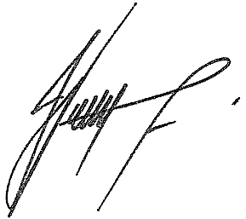

IMRE NAGY
DIRECTOR: INSPECTIONS

