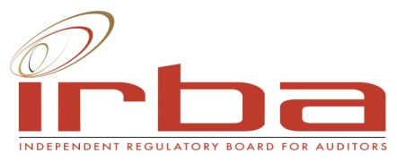

SBD 3.3
PRICING SCHEDULE
(Professional Services)

NAME OF BIDDER: ………………………………………………………………………………………………BID NO.: IRBA002/2016

CLOSING TIME :12:00 CLOSING DATE: 15 DECEMBER 2017

OFFER TO BE VALID FOR 90 DAYS FROM THE CLOSING DATE OF BID

DESCRIPTION BID PRICE IN RSA CURRENCY
INVITATION TO REGISTER ON THE IRBA PANEL OF ATTORNEYS DATABASE **(ALL APPLICABLE TAXES INCLUDED)

The accompanying information must be used for the formulation of proposals.

Kindly indicate the price/cost per hour for each level of person included in the proposal.

Level | Cost per Hour (R)
Partner level 5 − >15 years’ experience
Partner level 4 − >8 years’ experience
Associate level 3 − >5 years’ experience
Prof assistant level 2 − <5 years’ experience
Candidate Attorney − Level 1

