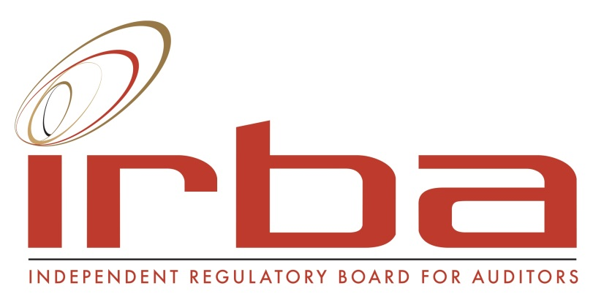

MEDIA STATEMENT

South Africa maintains first position for the strength of Auditing and Reporting Standards for six years in a row
Wednesday, 30 September. For the sixth year in a row, South Africa has been ranked number one – out of 140 countries – for the strength of its auditing and reporting standards, according to the World Economic Forum’s (WEF) Global Competitiveness Index for 2015-2016 released today.
The ranking brings confidence to foreign investors that they can trust and rely on our auditing strength despite the economic meltdown and other challenges that the country and the auditing profession have been experiencing.
“We are proud to have achieved such a world renowned ranking for six years in a row now. More importantly, this ranking further strengthens the IRBA’s role as an embedded protector of confidence in the sustainability of the system. Such confidence provides the required comfort to a wide range of stakeholders that the financial statements on which auditors express assurance are reliable, therefore enabling investors to make informed decisions about their investments,” says Bernard Agulhas, CEO of the Independent Regulatory Board for Auditors (IRBA).
The index assesses the competitiveness of economies, providing insight into the drivers of productivity and prosperity by examining various factors that enable sustained economic growth. The ranking remains the most comprehensive assessment of national competitiveness worldwide.
South Africa’s decision to adopt the globally recognised International Standards on Auditing (ISA) as well as the International Financial Reporting Standards (IFRS) as early as 2005 has had a direct effect on South Africa’s leading ranking in this section of the report.
“Foreign investment into South Africa stimulates economic growth for the nation and creates employment. It is encouraging that our achievement as a respected player in the global financial markets contributes to the country’s national imperatives. Therefore, we should also focus on social sustainability to address unemployment issues,” says Agulhas.
He emphasises that South Africa, which has moved up the overall rankings to number 49 from 53, also has a vital role to play in supporting other countries on the continent to improve their financial standards and reporting processes so that Africa can become internationally respected in global markets. In addition, developing countries need to create stronger ties among themselves, with greater collaboration between the private and public sectors as well as between industry and government.
While recognising that it has a role to play in strengthening reporting and governance on the continent, the IRBA has also developed strategies to influence transformation in the auditing profession, as well as respond to global developments to strengthen auditor independence.
“As the custodian of the auditing profession, the IRBA, together with the profession, must maintain the quality and integrity of the audit system, thereby contributing to the protection of the financial interests of the public,” concludes Agulhas.
For more information on this year’s World Economic Forum Global Competitiveness Report, please visit www.weforum.org. ENDS.

Issued by the Independent Regulatory Board for Auditors
For more information contact:
Lebogang Manganye
Email: lmanganye@irba.co.za
Tel: 087 940 8788
Cell: 084 510 4658

